Instructions on How to Use the Evaluation Report Grids and Word Document

Step 1:
On the www.AmericaInBloom.org/Advisors-Forms page, click on and then save these two files to the location of your preference (hard drive, cloud account, etc):
- “Excel Grids for Scoring”
- “Word Document for Advisors to Use to Write Evaluation and to Insert Excel Grid Scores”
These are your original source files. Do not enter data in these. Keep these are original files that you can use in the event of an error that you can’t seem to correct when working on a community’s evaluation.

Step 2:
- Create a folder for each of the communities you will evaluate.

Step 3:
- Copy into each of your community folders the two sources files referenced in Step 1 (Excel grids and Word document). These will be the files you use when scoring and writing the evaluation for each community.
- You may rename the files to anything you wish.

Step 4: Using the “Grids for Evaluation Report” excel workbook
- Open the file in your first community’s folder.
- You will see there are tabs at the bottom that correspond to the various criteria.
- DO NOT enter any data in the sheet called “Page 1 grid.” This tab/sheet is linked to the other grids so that the metrics entered throughout various tabs will appear here.
- The other tabs at the bottom will be where you enter your scores for each category/criterion.
- To score each row, you MUST enter a Capital X.
  - If you happen to use a different character or enter two values on the same row, you will receive an error message.
- Enter your score for EACH row in each of the tabs/grids. You MUST provide a score for EACH row, even if it’s an N/A.
  - Reminder: Each tab has a row called “Advisors’ Discretion: Recognition by advisors of an item of special note.” You MUST score that row, even if it’s an N/A. If you do score that row, please ensure you provide text to explain what you are recognizing.
- There are hundreds(!) of formulas set up in this workbook that will automatically tabulate your scores on each grid and will link the data back to the Page 1 grid tab. Each time you make an adjustment to one of the tabs, the Page 1 grid tab will automatically update. Reminder, do NOT enter data in Page 1 grid tab.

Step 5: Using the “Word Document for Advisors to Use to Write Evaluation and to Insert Excel Grid Scores” document
- Open the word document.
- Enter all the pertinent information throughout the document, including recommendations for each criterion, and the various recognitions that are required at the end of the evaluation report.
- NOTE: It is recommended to complete all parts of the word document BEFORE dealing with inserting each of the excel grids into the evaluation report. Inserting the grids is addressed in Step 6.

Step 6: Inserting the various excel grids into the word document
Note: For those of you extremely proficient in linking the excel files with the word document, you may feel up to the challenge of linking the two. This is not for the faint of heart, and if you are not 100% confident, then follow the next steps instead.
- There are notes within the word document referencing where to insert the various grids.
- Remove the highlighted text, and then simply copy/paste each of the grids/tabs where it says to do so in the word document.
- When copying and pasting the grids, only copy the cells in the grid. Do not Copy All, which copies the entire page including blank cells that do not need to be included in your evaluation report.

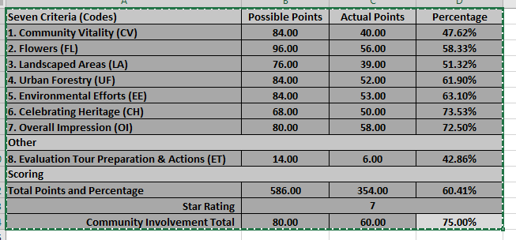

Here is a screenshot from my computer. Notice the green dotted line. That indicates what I have copied.
You will see that I ONLY copied the cells that are part of the grid. I did not copy empty cells. This will make it easier to keep the formatting when you paste it in the word document.

- Once you’ve copied the appropriate cells in Excel, go to the correct location in your Word document and copy it.
- Word should automatically default to keeping the formatting from your excel file.
  - If it does not keep the formatting: When you are ready to paste, right click, select “Paste” and you will see some options appear. Select the option that reads “Keep Source Formatting.”
- Do not be intimated by the instructions. This sounds more difficult than it is. This is simply a copy/paste function.
- Do this with each of the grids throughout the word document.
REMINDER: If you decide to update your scores after you’ve copied them into your word document, you must re-enter your scores in your excel file. Then copy/paste the new data back into the word document.

Miscellaneous
- Do not get too hung up on formatting the word document. Laura will clean up documents that need some assistance. Your priority should be scoring the communities in a fair and accurate manner, while providing valuable and constructive feedback and recommendations.
- This evaluation report has very complex formulas driving the scoring tabulations. While the formulas have been tested, it is recommended that you to check your math anyway.
- If you have any questions, concerns, stumbles along the way, please let Laura know so assistance can be provided right away.

