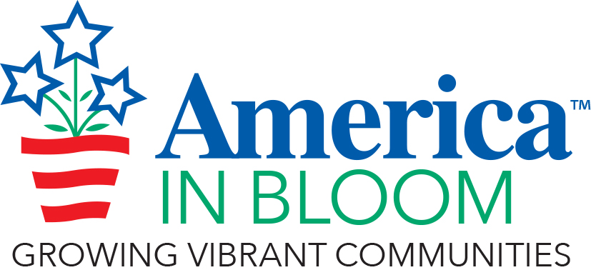

Enter your community’s name and state here

2023 Community Profile

Instructions for using this template:

Please email a PDF version of the Community Profile to the AIB office at aib@AmericaInBloom.org at least two weeks prior to the first evaluation date. The office will ensure your team of advisors receives a copy prior to their arrival in your community.

Use this template to simplify the creation of your Community Profile – a required part of your America in Bloom participation. Many communities find the finished product has many uses, such as an economic and tourism development tool, attract new residents, addendum to grant applications, an important historic document, and even as a fundraising tool.

This profile is an important collection of your achievements and is part of your history. Post it on the website and provide copies to city hall, chamber of commerce, visitor’s bureau, historical society, library, business leaders, real estate agents, and other stakeholders.

To complete the template:
- Fill in the requested information on each page.
- Add photos if you wish. Be sure each photo has a caption to further tell your story. Remember, when adding photos to compress them to about 220dpi which is good for printing and allows the file to be emailed easily.
- The maximum page count is 25 pages.
- When finished with the document, delete this instruction page and any shaded sections – they are for your reference only and are provided as prompts for information to include.
- If you have participated in AIB in the past, highlight what is new and/or implemented from previous advisor recommendations.

If you have additional materials such as more photos, brochures, newspaper clippings, etc., make them available in a separate file/binder. The advisors may, at their discretion, take this additional binder with them, ask that it be mailed directly to them, or they may refer to the binder while in your community and then leave it with you.

Contact Information
Contact person:
Email:
Phone (primary):
Phone (secondary):
AIB committee chair contact and/or volunteer coordinator (if different from name listed above). Please include name, email, and phone number(s):

Community Information
Population:
County/township:
Municipal Website:
Municipal Facebook page:
Area in square miles:
Acres of active recreation:
Acres of passive recreation:
Form of government (mayor, council, manager, etc.):
Jurisdiction(s) operates the public-school system:
Jurisdiction operates the utilities (water, sewer, electrical, trash, recycling, etc.):
Volunteer coordinator name if position exists:
Any challenges this year weather-related or otherwise the advisors should know about:
Years participated in America in Bloom Program:
Previous America in Bloom Awards and Recognitions:

Introduction to your community (500 words or less):

COMMUNITY VITALITY
Policies, programs, activities, and facilities that lead to a vibrant community and promote a sense of health and well-being. Includes, but not limited to, senior and community centers, libraries, museums, arts/cultural organizations, mentoring programs, schools, faith-based organizations, parks, playgrounds, dog parks, sports fields, water activities, trails, golf courses, and other active and passive recreational opportunities for all ages and abilities.

PROVIDE AN OVERVIEW OF EFFORTS IN COMMUNITY VITALITY.
Insert photos as desired (no more than 3). If you are a returning community, include what is new and implemented from previous Advisor recommendations.

FLORAL IMPACT
Strategic design, use, installation, and maintenance of floral displays and seasonal accents for beautification, including but not limited to annuals, perennials, bulbs, tropical plants, flowering topiaries, colorful foliage, and cultivated and native plants for season-round interest for displays in containers, hanging baskets, window boxes, raised planters, trellises, and in-ground plantings.

PROVIDE AN OVERVIEW OF EFFORTS IN FLORAL IMPACT.
Insert photos as desired (no more than 3). If you are a returning community, include what is new and implemented from previous Advisor recommendations.

LANDSCAPED AREAS
Strategic design, use, installation, and maintenance of the managed landscape. This includes hardscape features, cultivated and native trees, shrubs, ornamental grasses, vines, succulents, edibles, evergreen topiaries, turf, groundcovers, and pollinator-friendly plant material.

PROVIDE AN OVERVIEW OF EFFORTS IN LANDSCAPED AREAS.
Insert photos as desired (no more than 3). If you are a returning community, include what is new and implemented from previous Advisor recommendations.

URBAN FORESTRY
Strategic design, use, installation, and maintenance of trees on public and private lands.

PROVIDE AN OVERVIEW OF EFFORTS IN URBAN FORESTRY.
Insert photos as desired (no more than 3). If you are a returning community, include what is new and implemented from previous Advisor recommendations.

ENVIRONMENTAL INITIATVES
Environmental and sustainable leadership, policies, plans, and programs for water, resource conservation; pollution control; trash, recycling, and reuse; climate change issues, green Infrastructure, and alternative energy resources.

PROVIDE AN OVERVIEW OF EFFORTS IN ENVIRONMENTAL INITIATIVES.
Insert photos as desired (no more than 3). If you are a returning community, include what is new and implemented from previous Advisor recommendations.

CELEBRATING HERITAGE
Recognition, designation, protection, commemoration, and celebration of historical, cultural, natural, agricultural, and industrial resources.

PROVIDE AN OVERVIEW OF EFFORTS IN CELEBRATING HERITAGE.
Insert photos as desired (no more than 3). If you are a returning community, include what is new and implemented from previous Advisor recommendations.

OVERALL IMPRESSION
Adequate and effective amenities are provided and in good condition. The community is welcoming, attractive, and leaves a positive impression.

PROVIDE AN OVERVIEW OF EFFORTS IN OVERALL IMPRESSION.
Insert photos as desired (no more than 3). If you are a returning community, include what is new and implemented from previous Advisor recommendations.

BEST IDEA
Using the America in Bloom criteria to guide your thinking, what is the best idea your community has this year? 500 words or less. Please include no more than 3 pictures.

COMMUNITY CONTACTS

Provide information about people the advisors will meet or who can provide FOLLOW-UP information about your community. Add more lines if necessary.

Name | Affiliation/Title | Email | Phone

ADVISOR VISIT ITINERARY

Day 1:

Day 2:

INSERT COMMUNITY MAP

