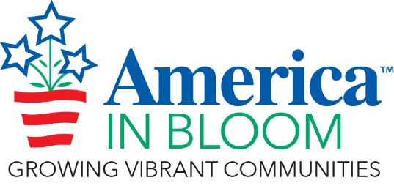
SPECIAL AWARD NOMINATION FORM

Rules & Guidelines
- The objective for each Special Award is to recognize an overall winner of excellence in each of the award categories.
- You may submit nominations for as many awards as you wish.
- Describe the reasons to justify the nomination.
- Photos (maximum of seven, compressed) are helpful where applicable.
- There is no word limit on nominations but please keep the text and photos to a maximum of 4 pages.

Your Community/State:

2023 Special Award Name (choose from list below):

Click here for a description of each award.

- Coolest Downtown
- Coolest Place for Kids
- Best Community Garden Program
- Eye-Popping Pots – Best Use of Containers in the Landscape
- Best Youth Gardening Program
- What’s Old Is New Again – Best Adaptive Reuse Project
- Innovation in Action – Most Impressive New Project or Program
- Better Together – Best Example of Public/Private Partnership
- Best Volunteer Recognition Program
- Best Mural Program
- Youth Involvement Award
- Alive with Flowers – Sunbeam Social Media Award
- Catching Community Spirit – Digital & Social Media Communications

Add your nomination text and pictures (compressed) here:

