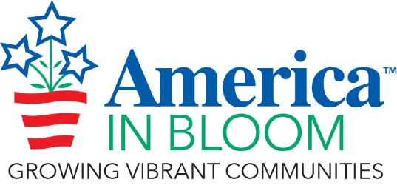
SPECIAL AWARD NOMINATION FORM

Rules & Guidelines
- The objective for each Special Award is to recognize an overall winner of excellence in each of the award categories.
- You may submit nominations for as many awards as you wish.
- Describe the reasons to justify the nomination.
- Photos (maximum of seven, compressed) are helpful where applicable.
- There is no word limit on nominations but please keep the text and photos to a maximum of 4 pages.

Your Community/State:

2024 Special Award Name (choose from list below):

Click here for a description of each award.

- Youth Involvement Award
- Flower Power – Best Hanging Basket Program
- Coolest Downtown
- Coolest Place for Kids
- Eye-Popping Pots – Best Use of Containers in the Landscape
- Best Youth Gardening Program
- Best Volunteer Recognition Program
- What’s Old Is New Again – Best Transformation Project
- Best Tree Inventory Program
- Protecting the Planet – Best Environmental Garden Program
- Most Welcoming Community – A Celebration of Community Diversity
- Economic Impact – Best Program for Local Business
- Alive with Flowers – Sunbeam Social Media Award

Add your nomination text and pictures (compressed) here:

