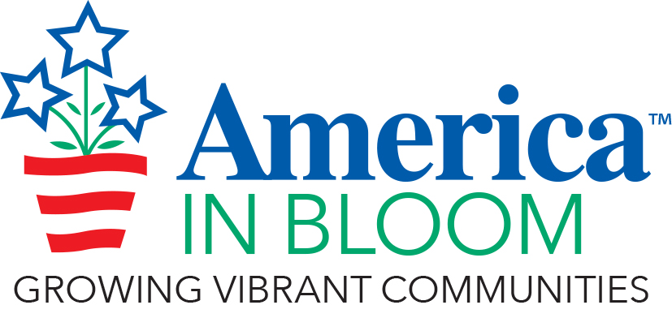 Outstanding Achievement Award Nomination Form

Community/State:

Criterion Being Nominated:
(Select one: Flowers, Landscaped Areas, Urban Forestry, Environmental Efforts, Celebrating Heritage, Community Vitality, Overall Impression. You may also nominate your community for its Community Involvement efforts)

- The objective for the Outstanding Achievement Award is to recognize an overall winner of excellence in each of the seven evaluation criteria plus community involvement.
- Describe and give the reasons to justify the nomination.
- Photos (maximum of seven, compressed) are helpful where applicable.
- There is no word limit on nominations but keep the text and photos to a maximum of four pages.
- One winner for each category will be selected from all of the participants.
- Send nominations to the AIB office at aib@americainbloom.org.

Add your nomination text and pictures (compressed) here:

