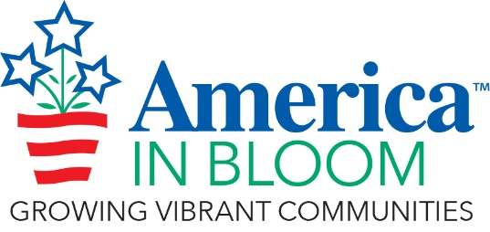
SPECIAL AWARD NOMINATION FORM

Rules & Guidelines
- The objective for each Special Award is to recognize an overall winner of excellence in each of the award categories.
- You may submit nominations for as many awards as you wish.
- Describe the reasons to justify the nomination.
- Photos (maximum of seven, compressed) are helpful where applicable.
- There is no word limit on nominations but please keep the text and photos to a maximum of 4 pages.

Your Community/State:

2026 Special Award Name (choose from list below):

View a description of each award by going to: https://americainbloom.org/wp-content/uploads/2022/03/2026-AIB-Special-Award-Descriptions.pdf

- Stars & Stripes Celebration Award
- Back to Our Roots – Best Use of Native Plants
- First Impressions – Gateways Award
- Beauty Through the Seasons Award
- Bloom Equity Award
- Hidden Gem Award
- Trash Talker – Best Clean-Up Program
- Art in the Landscape Award
- Best Pocket Park
- Flower Power – Best Hanging Basket Program
- Eye-Popping Pots – Best Use of Containers in the Landscape
- Coolest Downtown
- Therapeutic Gardening Award
- Focused on Fitness – Promoting Healthy Living Through Community Design
- Buds to Bloom – Youth Involvement Award
- Partnership Power – Best Collaborative Project

Add your nomination text and pictures (compressed) here:

